Instructions for Patients with Cough or Trouble Breathing:

Please try to not spend a lot of time lying flat on your back! Laying on your stomach and in different positions will help your body to get air into all areas of your lung.
Your healthcare team recommends trying to change your position every 30 minutes to 2 hours and even sitting up is better than laying on your back. If you can, please try this:
1. 30 minutes – 2 hours: lying on your belly
2. 30 minutes – 2 hours: lying on your right side
3. 30 minutes – 2 hours: sitting up
4. 30 minutes – 2 hours: lying on your left side; then back to position #1.
PHOTOS BELOW TO DEMONSTRATE THIS:

1. 30 Minutes – 2 hours: Laying on your belly
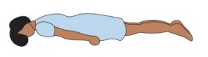
2. 30 minutes – 2 hours: Laying on your right side
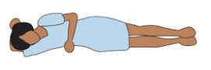
3. 30 minutes – 2 hours: Sitting up
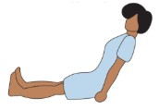

4. 30 minutes – 2 hours: Laying on your left side
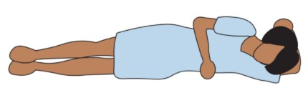
Then back to position 1! Laying on your belly.
